HOMEWORK 3

Calculating Optical Flow

**Student Name**: Rohit Das **Student ID**: 61047086s

**Objective**: Calculating optical flow using specific algorithm and synthetically translate lena.bmp one pixel right and downward

**Algorithm Used**: Horn and Schunck Optical Flow Estimation

**Screenshot of the Algorithm:**

Call Gradient:

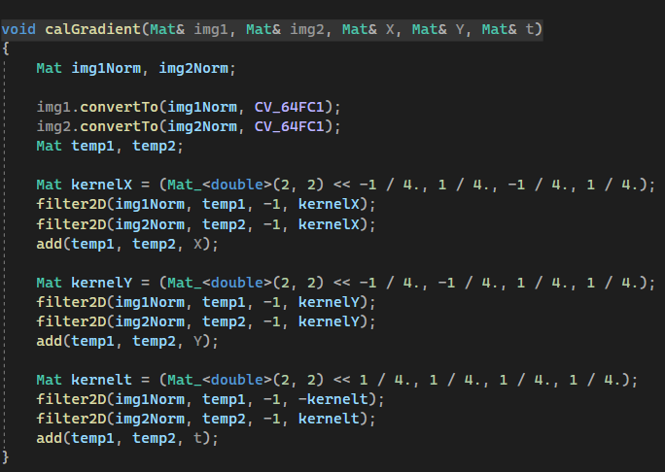

Horn and Schunk Calculation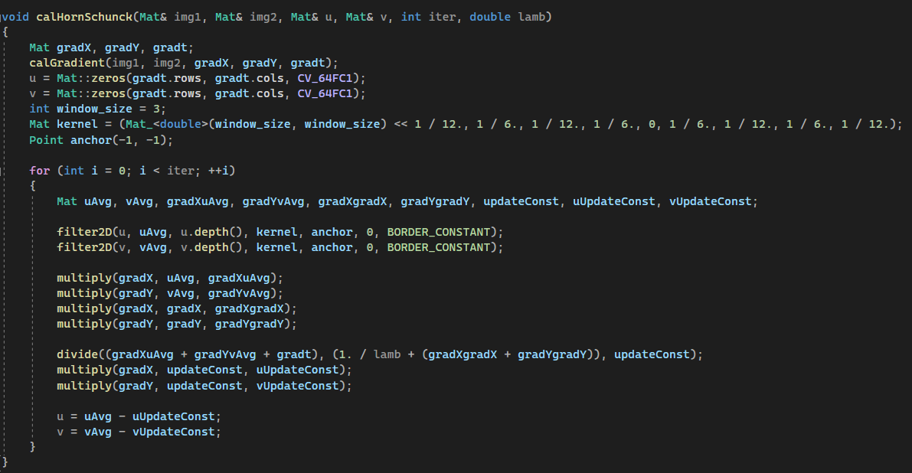

Draw optical Flow:

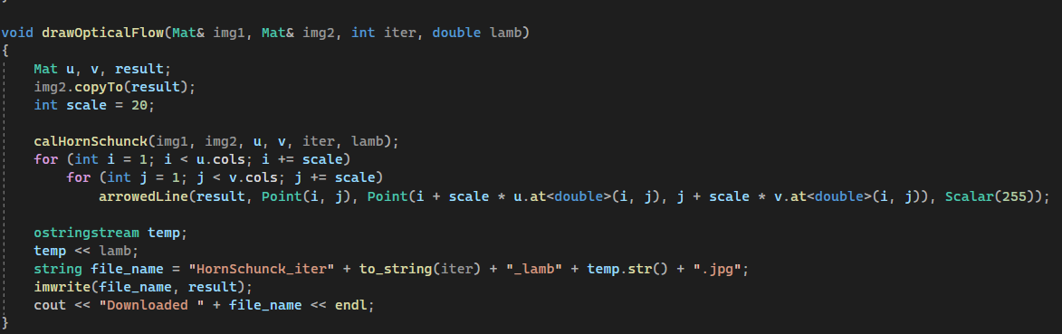

**Results**

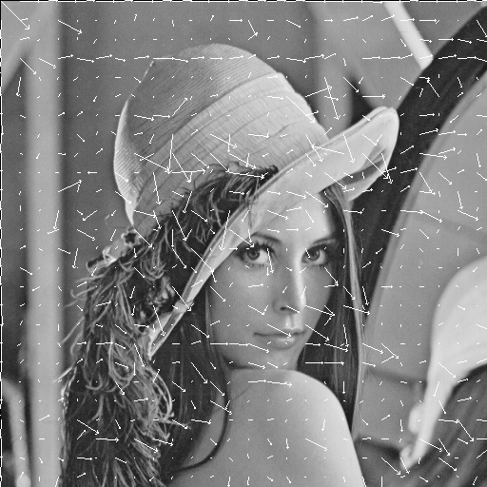 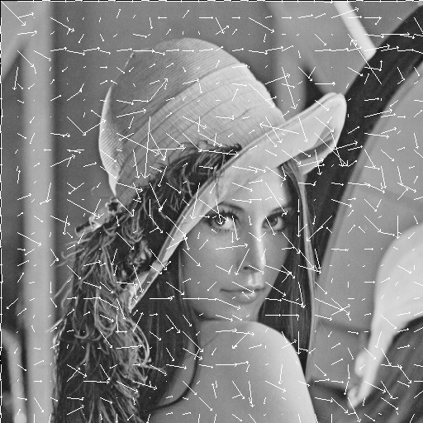

**HornSchunck_iter1_lamb0.1 HornSchunck_iter1_lamb1**

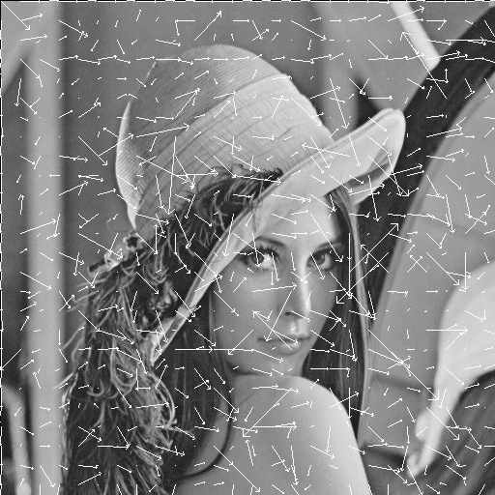 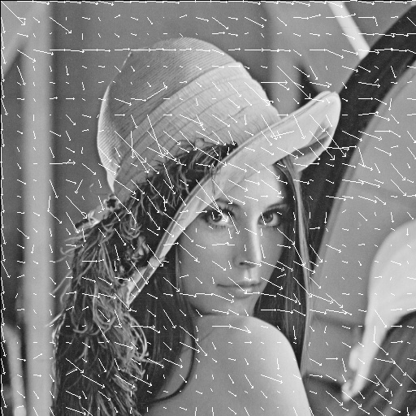

**HornSchunck_iter1_lamb10 HornSchunck_iter4_lamb0.1**

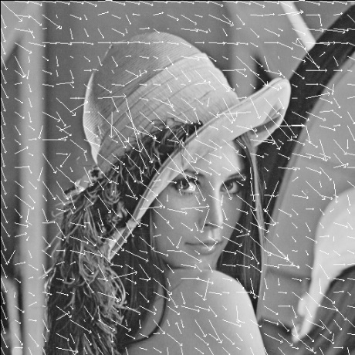 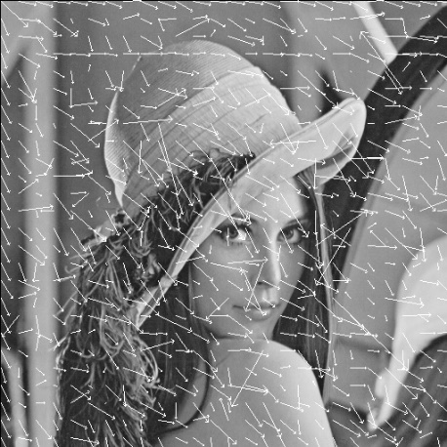

**HornSchunck_iter4_lamb1 HornSchunck_iter4_lamb10**

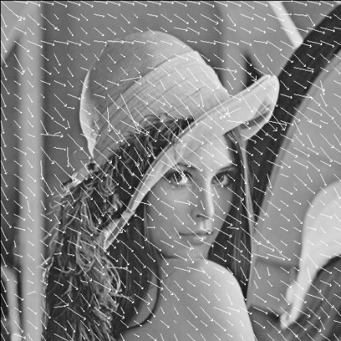 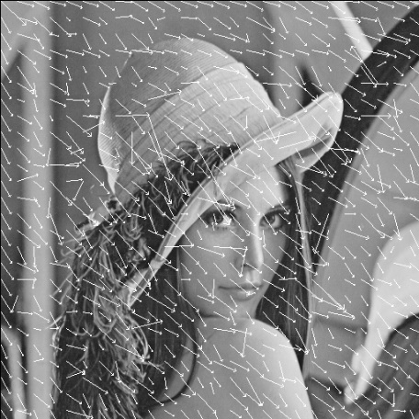

**HornSchunck_iter16_lamb0.1 HornSchunck_iter16_lamb1**

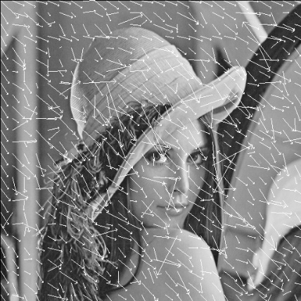 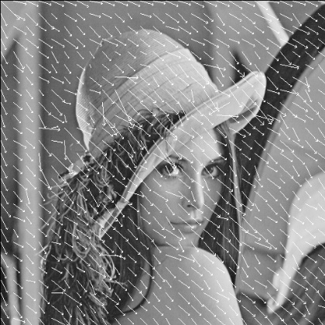

**HornSchunck_iter16_lamb10 HornSchunck_iter64_lamb0.1**

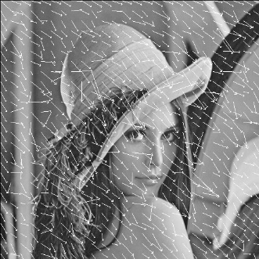 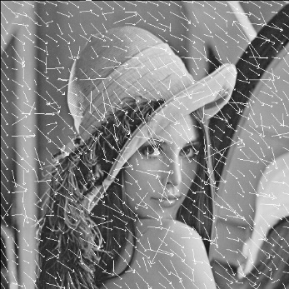

**HornSchunck_iter64_lamb1 HornSchunck_iter64_lamb10**